EUIPO workshop on IP tools in Zimbabwe

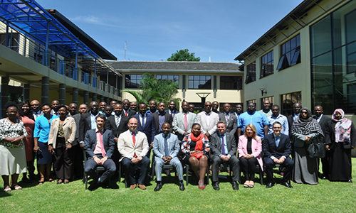

A Technical Workshop on Tools, organised under the framework of the EUIPO’s international cooperation activities, is taking place in the headquarters of the African Regional Intellectual Property Organization (ARIPO) in Harare, Zimbabwe on 27-29 November 2019.

The workshop, developed under the European Union Intellectual Property Network (EUIPN), gathered representatives from ARIPO, the Industrial Property offices of 16 Member States of ARIPO, and Nigeria.

EUIPO and ARIPO also signed an addendum of the **Memorandum of Understanding to foster cooperation** between both organisations.

The workshop aims to identify tools of interest for the participating offices and to define future activities for the upcoming EU-funded Pan-African project in the field of Intellectual Property Rights, which will be soon implemented by the EUIPO.

This initiative enables a collaborative platform among participating offices, allowing the exchange of information and experiences to reinforce cooperation. In particular, the participating offices will focus on **extending the benefits of the EUIPN tools, in particular TMview**.

The EUIPO’s 2020 vision is to deliver high-quality products and services to trade mark and design users, which requires expanding its focus to the international arena, as set out in the Strategic Plan 2020 (SP2020). In particular, Line of Action 4 of the SP2020, supporting its Strategic Goal 3 ‘Building network convergence with global impact’, includes the Office’s strategy to extend the benefits of the tools and practices developed by the EUIPN beyond the borders of the EU, in the interest of users.

As part of this strategy, since 2017, EUIPO has hosted technical workshops with non-EU IP offices in Latin America, Africa, Asia and Oceania, thus increasing the outreach of the Network’s tools and practices globally.